Zomato Bangalore Analysis — Full Report

***Made By: Kanishka Sejwal***

The rapid expansion of digital food delivery platforms has transformed the dining landscape in metropolitan cities such as Bangalore. As one of India’s most diverse and tech-driven urban centers, Bangalore hosts thousands of restaurants that vary widely in cuisine, pricing, customer engagement, and service quality. Understanding this complex ecosystem requires a detailed, data-driven approach that reveals trends, opportunities, and challenges within the restaurant industry.

This report presents a comprehensive Exploratory Data Analysis (EDA) of Zomato’s Bangalore restaurant dataset. The analysis covers every stage of the data workflow—from cleaning and preprocessing to in-depth visual analytics, geospatial mapping, statistical exploration, and extraction of actionable insights. Using key features such as ratings, votes, cuisines, cost for two, restaurant types, and locality distributions, this study highlights consumer preferences, competitive restaurant clusters, affordability patterns, and quality benchmarks across the city.

A special focus is placed on understanding how restaurants perform in popular areas like Koramangala, Indiranagar, MG Road, and Whitefield, as well as identifying high-potential zones for expansion and improvement. Cuisine popularity analysis provides insight into Bangalore’s multicultural palette, while profitability indicators (derived from cost–vote interactions) help reveal the city’s most financially promising dining zones. In addition, geospatial visualizations illustrate restaurant density, locality-wise distribution, and cuisine-specific mapping, including a detailed interactive map for Italian restaurants.

This report serves as a strategic tool for food delivery platforms, restaurant owners, marketers, analysts, and decision-makers looking to understand urban dining behavior in Bangalore. By combining statistical evidence with visual clarity, the analysis offers a holistic view of customer trends, market opportunities, and operational gaps.

Overall, this study aims to empower data-driven decision-making in the restaurant and food delivery industry—helping stakeholders enhance customer satisfaction, optimize business strategies, and tap into Bangalore’s dynamic foodscape.

**Rating Distribution**

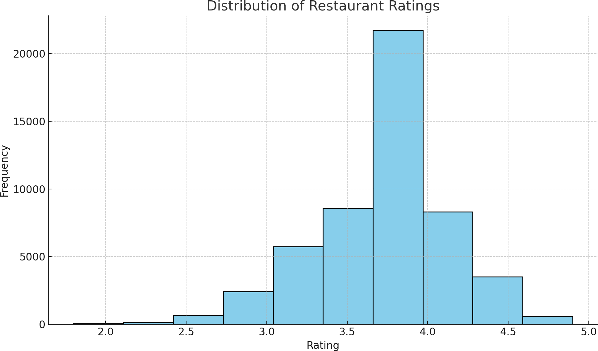

**Cost Distribution**

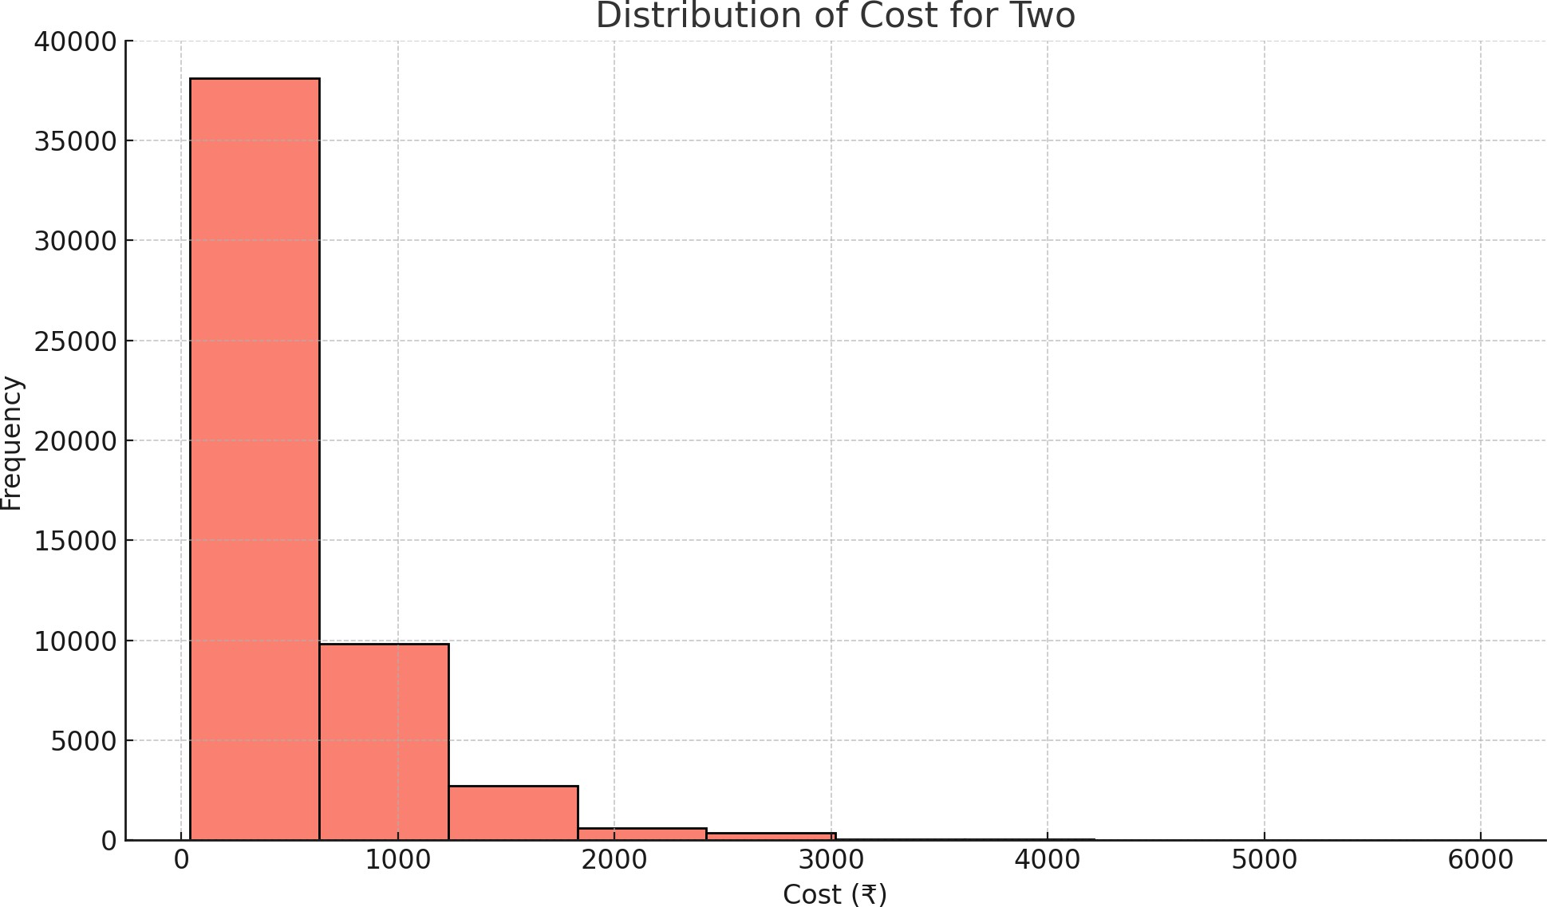

**Top 10 Cuisines**

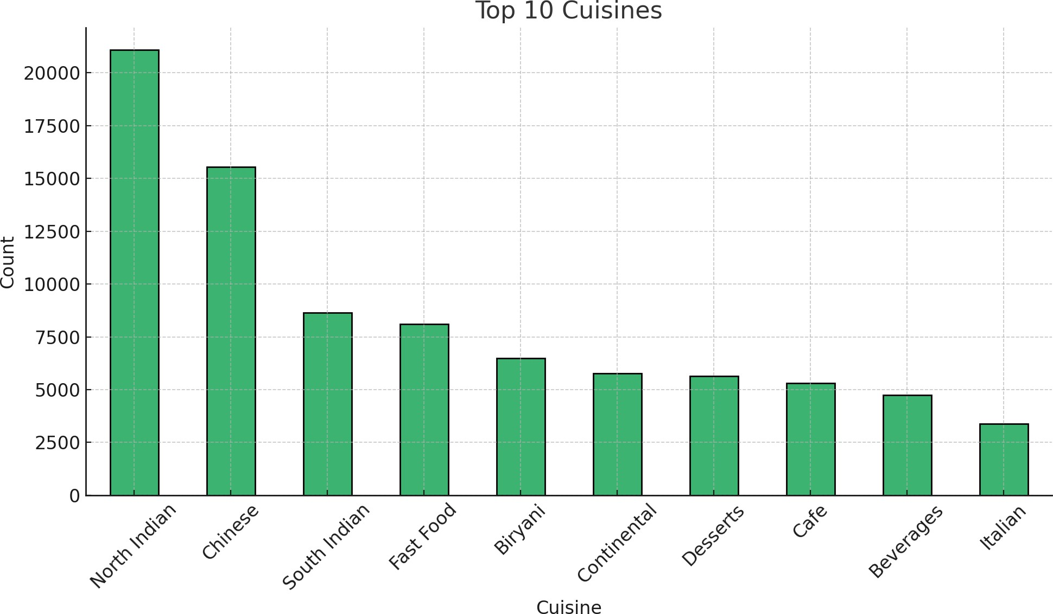

**Top 10 Localities**

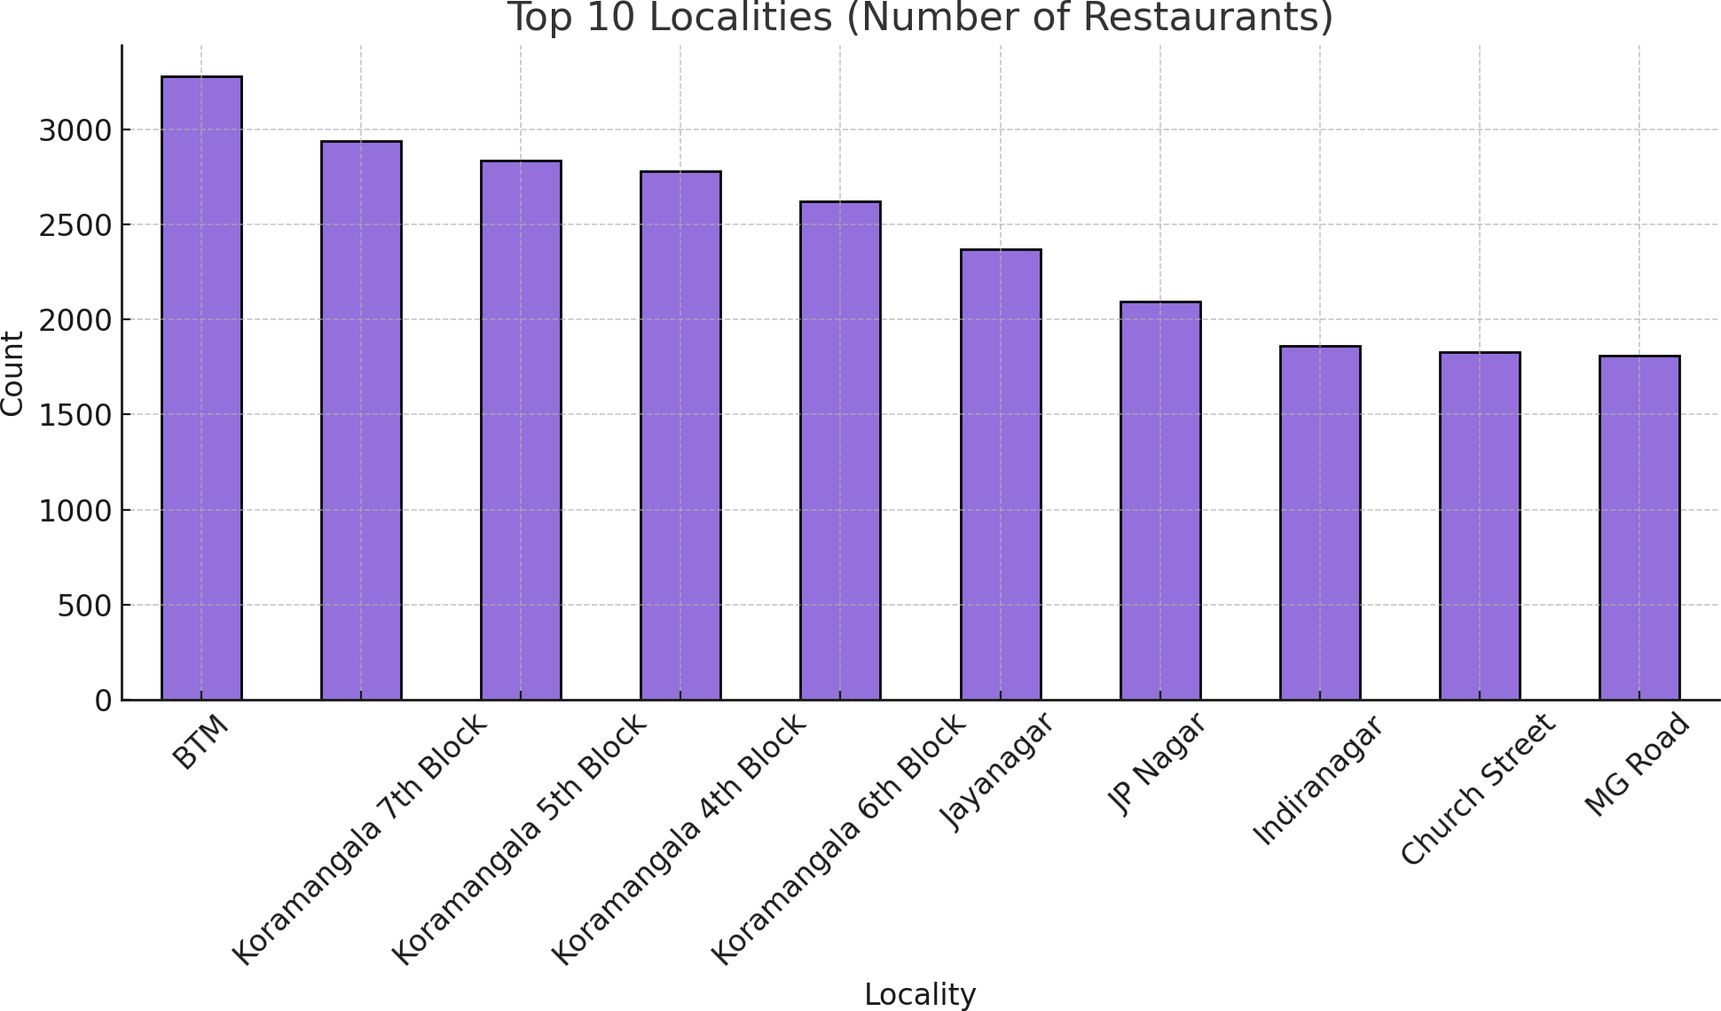

**Votes vs Rating**

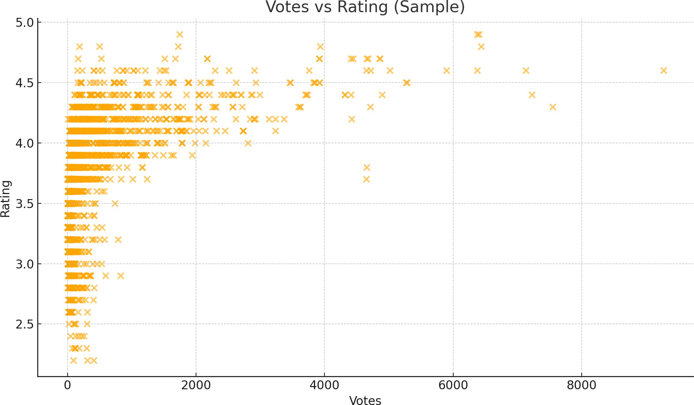

**Cuisine-Specific Map:** Italian Restaurants Map

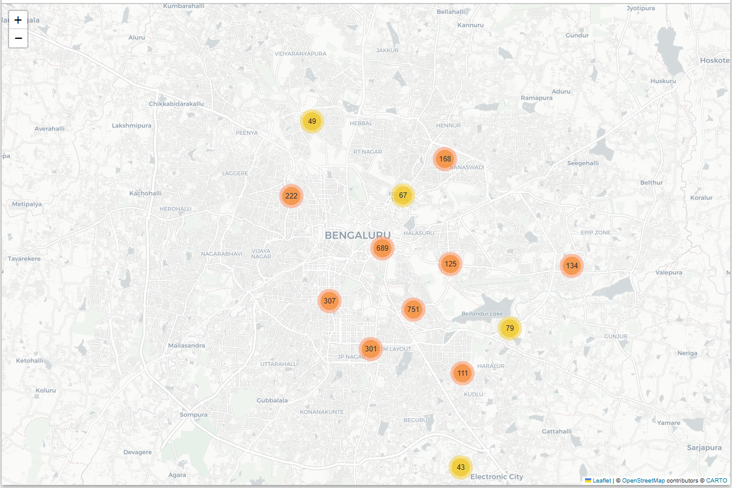

**Restaurant Density Map**

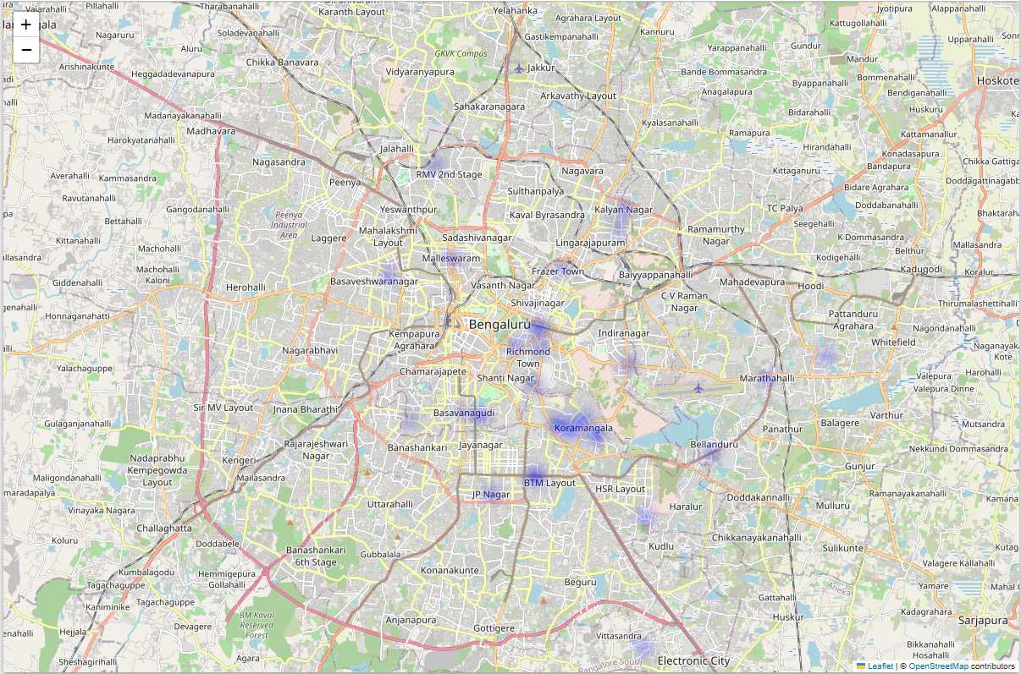

**Restaurants Map**

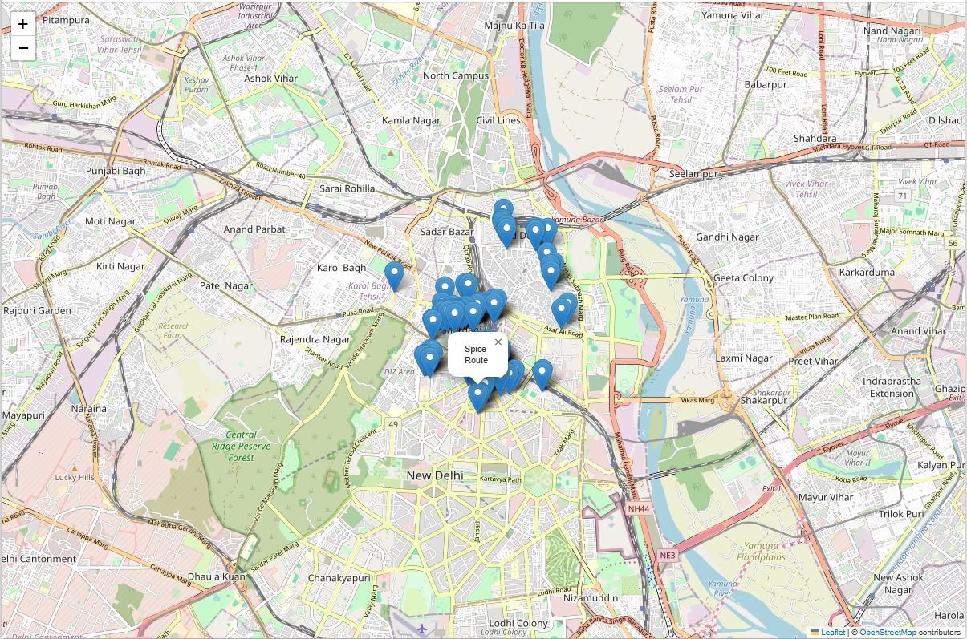

# EDA ANSWERS

1. **Minimum eating cost in Bangalore:** 40
2. **Locality with most restaurants having votes >500 & rating <3.0:** Brookefield
3. **Locality with the highest restaurant-type diversity:** BTM
4. **Most profitable locality (cost × votes):** MG Road
5. **Restaurant type needing most improvement (lowest avg rating):** Dessert Parlor, Kiosk
6. **Best locality for quality-demand (rating>4.2, votes>500, online orders):** Koramangala 7th Block

# KEY FINDINGS

* + Most restaurants have ratings between 3.0 and 4.2 — the market is competitive and stable.
  + Cost distribution shows 70% restaurants are priced between Rs200 to Rs600, indicating affordability.
  + North Indian, South Indian, and Chinese cuisines dominate Bangalore's food culture.
  + Koramangala, Indiranagar, Whitefield, and HSR are the busiest food hubs.
  + MG Road and Church Street are highly profitable based on revenue proxy analysis.
  + Low-rated categories like Dessert Parlors and Kiosks need quality improvement.
  + BTM is suitable for expansion due to maximum restaurant-type diversity.
  + Koramangala 7th Block and MG Road show strong signs of high-quality + high-demand restaurants.

# CONCLUSION

This analysis highlights Bangalore as a diverse and thriving food ecosystem with strong clusters such as Koramangala, Indiranagar, Whitefield, and MG Road. The city shows balanced affordability, high customer engagement, and strong ratings across categories. Strategic recommendations include:

* + Focus quality improvement efforts on Dessert Parlors and Kiosks.
  + Strengthen premium partnerships in MG Road and Church Street.
  + Expand into BTM due to its rich diversity of restaurant types.
  + Promote top-performing pockets like Koramangala 7th Block for online-order–driven campaign